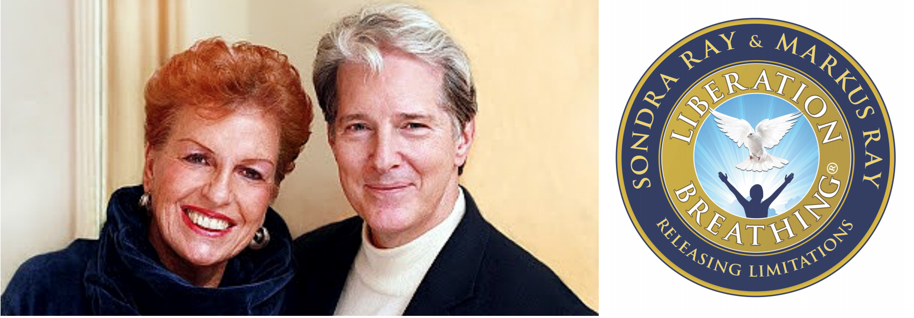
The Miracle Consciousness Training
“Deeper Connection, Communication, and Spiritual Intimacy”
SONDRA RAY & MARKUS RAY

Place: Empowerhouse, Indiakaj 10, 2100 Copenhagen

Time: Sat. the 23rd of June and Sun. the 24th of June 2018, 09.00-18.00.
A two-day seminar on shifting your mind and changing your life for the better. Let in the light!

On the 23rd and 24th of June 2018, on two days which on our side of the earth is filled with light - you are invited to participate in a 2-day seminar with international healers and teachers Sondra Ray and Markus Ray. Sondra and Markus have 50 years of experience as spiritual teachers of a Course of Miracles along with other spiritual teachings. Their method of Liberation Breathing® is a gentle, but powerful breathing technique designed to release negative thoughts and blocks. You will learn how you can use your breath in order to release all the potentials you have in your life – and you will see miracles happen!

“Miracles are everyone’s right, but purification is necessary first.”
ACIM Principle of Miracles #7

"YOUR BRIDGE to MIRACLES" is YOUR MIND

with a new Thought System!

Would you like to learn what a miracle is anyway?

It starts with a change of a thought. It starts with a declaration of everyone's innocence in a THOUGHT SYSTEM of JOY. We currently use a "thought system of problems and conflicts" — and seldom see that it is our own thought system that makes up these problems before they even happen! This thought system contains guilt, blame, victimhood, fear, anger and negativity. There is another thought system that we can choose. The thought system of immortal life that transcends these negative thoughts we have about ourselves and others — into a thought system of well-being, joy and trust.

We study A Course in Miracles which make these things very clear. It says Miracles are natural—and if they are not happening in your life, something has gone wrong. With Liberation Breathing® we look at our thoughts that are causing our problems — and then forgive them and breathe them out of our thought system. Then we have a NEW MIND that is more attuned to love, and less clogged up with thoughts and memories of problems.

At the workshop Sondra and Markus Ray will teach from the Course in Miracles, about various Spiritual Masters, and we will have different processes – both individual and in the group - and lots of breathing together!

Price: kr. 2300. Early bird before the 1st of June: kr. 1900.

Sign up via this link:

https://www.sondraray.com/event/miracle-consciousness-training-denmark

Get further information with the organizers:

Vibeke Lubanski, Vibeke.lubanski@live.dk, Mobile: 23466096.

and

Anka Lalatovic, anka@tolkeservice.dk, mobile: 22241014

OBS: it is possible to book individual sessions with Sondra and Markus on the 21st, 22nd, 25th and 26th of June. Price: kr. 1500.

